Welcome

Welcome to the 8-week Mindfulness Based Stress Reduction (MBSR) course
After each session you will receive handouts such as this. They are designed to support you through the course as something to be read and re-read; they can deepen your understanding, so please do dedicate time to read through them after each class and note any questions that may arise for you. You may wish to print them out if that helps. Always remember these notes are JUST FOR YOU- there is no handing in of work – so feel free to annotate them and add your own notes and thoughts if you want. Because these hand outs are for your eyes only, this means you can be as honest as you like with what you write and you can record things exactly as they are for you in that moment.
This course can be an intense experiential learning process and it is not unusual to find difficulties arising during the 8 weeks. Many times you will find the issues get discussed in class and are often brought up by someone else who is experiencing a similar thing. However, I am always available for a few minutes before and after each class for a one to one discussion. If you wish to talk about something between sessions or it is not possible to talk either side of the session, then please email me at Philip@trustingmind.co.uk and we can arrange a time to chat. But always remember facing and being with challenges is exactly the path we are on.

Session Guidelines
Here is a list of ways to make our sessions more useful and effective for all those involved.
- We all come from different backgrounds; some of you know one or more of the other participants, but all those roles and responsibilities and hierarchy are not important; here we are just human beings.
- You already have all the dates of the course. Note the all day retreat on Sunday 20th February and the delayed last session which will now be on 9th March and not the 2nd.
- Sessions are a mixture of longer, shorter practices, sitting and moving practices, reflection, small and whole group discussions. No one has to say anything in discussions, so don’t worry. Equally the moving practice is about exploring your own limits or edge and NOT going beyond. It is more about the awareness of movement than the perfection of the movement itself
- Wear loose comfortable clothing; if you have a yoga mat, do bring it but I have enough for everyone so don’t worry if you forget. However a blanket maybe useful for the first few sessions when you may be lying down for the body scans
- Please bring a drink with you to the session if you want. Deciding whether to eat before or after our weekly course will be a personal choice.
- If you think you can’t make a session please text or ring me beforehand. If you think you might be late – turn up anyway. ¾ of a session is better than no session.
- It will be important from the first session that we all take on board the idea of confidentiality. We all need to be confident that this is a safe space to talk. It is not a place for advice giving to other participants. It is mindful listening that is key
- These sessions are also present moment centred so please accept my apologies if I cut short any story telling and bring the group back to here and now.
- Thinking point: what do you want from each other out of the course? What’s important for you that will help you get the most out of the course?

Home practice is an important part of the course
The habits of the mind that we will be working to change have been around for a long time. These patterns are often automatic and deeply ingrained. We can only succeed in making changes in these long-held habits of mind if we put time and effort into learning new ways.
There will be time each session to reflect on your home practice. We will discuss any difficulties that you may be experiencing. The more you practice and the more you try to articulate your experiences, no matter how insignificant they may feel, the more you will get from the course.

Facing Difficulties
A central aim of the mindfulness approach is to learn how to be more fully aware and present in each moment. The good news is that this makes life more enjoyable, vivid and fulfilling. On the other hand, this means facing what is present, even when it is unpleasant and difficult. In the practices you will find that turning to face and acknowledge difficulties is, in the long run, the most effective way to reduce stress and of course you will throughout the 8 weeks be supported whilst doing this.

Patience and persistence
Because we will be working to change established patterns of mind, much of the approach will involve investing considerable time and effort, the efforts of which may only become apparent later. In many ways this is much like gardening. We have to prepare the ground, plant seeds, and ensure that they are adequately watered and nourished. Then we wait patiently for the results. The encouragement, therefore, is to approach this course with the same spirit of patience and persistence as a gardener. Commit yourself to put time and effort into what will be asked of you, home practice in particular, while accepting, with patience, that the fruits of your efforts may not show straight away.

Session 1 - An introduction to Mindfulness; awareness and automatic pilot
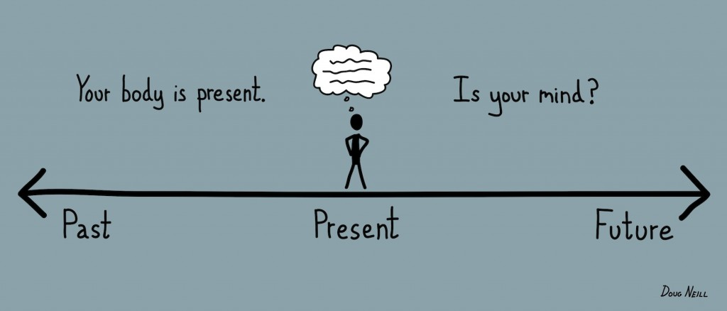
Autopilot mode can be useful. We would struggle to get through the day without it; forever checking on how to put one foot in front of the other, what the outside temperature is and how to walk from the bedroom to the kitchen. But it can also result in us missing out on life. Being on autopilot means we are more likely to have our buttons pressed and to react to events without stopping to think about it. By becoming more aware of our thoughts feelings and body sensations now and in the present moment we allow ourselves the opportunity for greater freedom as we can choose our response to what is happening. By doing this we avoid the blind knee jerk reaction and we will be able to respond in a kinder, more considerate fashion.
“Life was meant to be lived, and curiosity kept alive. One must never for whatever reason turn her back on life.”
Eleanor Roosevelt
Plus, in autopilot we might get carried away on the projections of the mind and believe that they are the truth, such as “I’m no good at this”, “I’m hopeless”, “Nobody really likes me”, “There’s no point to all of this”, “Why can’t I be like I used to be?” etc. etc. So, our inner dialogue can also be dominated by autopilot-thinking, which leaves us unsure about who or where we are.
Only when we commit to strengthening our ‘mindfulness muscle’ can we reclaim control of autopilot and the negative thoughts and emotions that it perpetuates. If left unchecked autopilot will happily mix up our emotions and sensitivities with judging and analysing because that’s what it does.

“Mindfulness is paying attention in a particular way… on purpose in the present moment without judgement with kindness.”
Jon Kabat-Zinn, 1990
To begin with this week we paid close attention to eating a raisin. This was to help us step out of autopilot. I asked you to consider these questions:
- What did you notice about eating with such focused attention on a single object? (physical/ mind/ mental)
- What was the relationship between your expectation of eating the raisin and the actual experience of eating the raisin?
- What , if anything, surprised you about this practice?
- Where elements of this practice you found challenging or easy?
- When your mind wandered where did it go?

The main practice this week and the one that will also form the bulk of your home practice was the body scan. If you have not followed a mindfulness practice like the body scan before you may find it a little difficult and confusing at times. This is quite normal and nothing to worry about. It is all part of cultivating a deeper awareness and understanding of how easily the mind can distract you with thoughts of boredom, frustration and impatience etc. Just stick with it and follow the instructions, as best you can. Below are the questions we considered in the session; reflecting on them after you practice the body scan at home may help you during the week as well.
- During the body scan, what did you notice?
- What was your experience with sensations in the body while you practiced the body scan?
- Where you aware of any ‘mind states’ such as agitation, confusion, lack of focus, attentiveness, etc. during this practice?
- Did you notice any emotions during the various stages of the body scan? If so, were these emotions connected to any parts or regions of the body?

If I Had My Life to Live Over

If I had my life to live over
I'd dare to make more mistakes next time.
I'd relax. I would limber up.
I would be sillier than I have been this trip.
I would take fewer things seriously.
I would take more chances.
I would take more trips.
I would climb more mountains and swim more rivers.
I would eat more ice cream and less beans.
I would perhaps have more actual troubles but I'd
have fewer imaginary ones.

You see, I'm one of those people who live sensibly
and sanely hour after hour, day after day.
Oh, I've had my moments and if I had it to do over
again, I'd have more of them. In fact,
I'd try to have nothing else. Just moments,
One after another, instead of living so many
years ahead of each day.

I've been one of those people who never go anywhere
without a thermometer, a hot water bottle, a raincoat
and a parachute.
If I had my life to live over, I would start barefoot
earlier in the spring and stay that way later in the fall.
If I had it to do again, I would travel lighter next time.
I would go to more dances.
I would ride more merry-go-rounds.
I would pick more daisies.

By Nadine Stair (age 85)
from Condensed Chicken Soup for the Soul
Copyright 1996 by Jack Canfield, Mark Victor Hansen & Patty Hansen

Home Practice – Week 1
1/ Complete a body scan practice every day. I will share with you via email links to a 30 and a 40 minute practice
2/ Try to informally create ‘mindful moments’ during your day. This will become easier over the course but to start with it may help to select an ordinary daily activity like brushing your teeth or making a cup of tea and try to do it mindfully. At every moment of the day it is always possible to stop doing and just be in the present.
3/ Eat mindfully once a day using the attitude and approach we applied with the raisin.
4/ Attempt the nine dot exercise and whilst you are doing so note any reactions and responses you have to doing it.
Instructions: Copy this on to some paper and draw four straight lines to connect all nine dots without lifting your pen or retracing any lines.
Make a note of your thoughts and feelings as you do this exercise, especially any temptation to google the answer!



